Issuing Bank
# Source: AI Source: Provided by: [Data Path: Persons Table -> ID Column: 1, Name_En Column: Motasem Essam] -> From: [ChatGPT] on [1/21/2026]
The issuing bank is the financial institution that provides payment cards (like credit or debit cards) to consumers and handles authorization, funding, and fraud protection for transactions made using those cards.

🧠 Simple Definition
# Source: AI Source: Provided by: [Data Path: Persons Table -> ID Column: 1, Name_En Column: Motasem Essam] -> From: [ChatGPT] on [1/21/2026]
An issuing bank is the bank that issues a card to the customer, manages their account, and pays the merchant on their behalf during a transaction.

🎯 Key Roles of the Issuing Bank
# Source: AI Source: Provided by: [Data Path: Persons Table -> ID Column: 1, Name_En Column: Motasem Essam] -> From: [ChatGPT] on [1/21/2026]
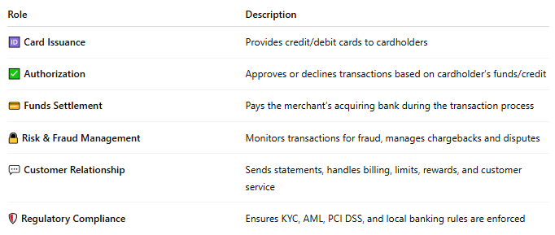
Role | Description
🆔 Card Issuance | Provides credit/debit cards to cardholders
✅ Authorization | Approves or declines transactions based on cardholder’s funds/credit
💳 Funds Settlement | Pays the merchant’s acquiring bank during the transaction process
🔒 Risk & Fraud Management | Monitors transactions for fraud, manages chargebacks and disputes
💬 Customer Relationship | Sends statements, handles billing, limits, rewards, and customer service
🛡️ Regulatory Compliance | Ensures KYC, AML, PCI DSS, and local banking rules are enforced

🔁 How It Works in a Transaction
# Source: AI Source: Provided by: [Data Path: Persons Table -> ID Column: 1, Name_En Column: Motasem Essam] -> From: [ChatGPT] on [1/21/2026]
Scenario: You use your card at a store
- You tap/swipe/enter your card to pay.
- The merchant’s POS system contacts the payment gateway, which contacts the card network (Visa, Mastercard).
- The card network routes the request to your issuing bank.
- The issuing bank checks your balance or credit limit.
- If all is OK, it authorizes the payment and guarantees payment to the merchant’s bank.
- Later, you’ll repay the bank (credit card) or it will deduct from your account (debit card).

📌 Examples of Issuing Banks
# Source: AI Source: Provided by: [Data Path: Persons Table -> ID Column: 1, Name_En Column: Motasem Essam] -> From: [ChatGPT] on [1/21/2026]
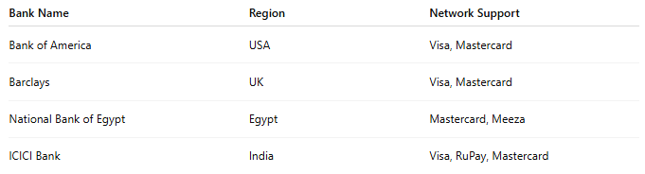

Bank Name | Region | Network Support
Bank of America | USA | Visa, Mastercard
Barclays | UK | Visa, Mastercard
National Bank of Egypt | Egypt | Mastercard, Meeza
ICICI Bank | India | Visa, RuPay, Mastercard

✅ Why Issuing Banks Matter
# Source: AI Source: Provided by: [Data Path: Persons Table -> ID Column: 1, Name_En Column: Motasem Essam] -> From: [ChatGPT] on [1/21/2026]


Benefit | To the Cardholder
💰 Credit availability | Enables borrowing for purchases
🧾 Purchase tracking | Statements and budgeting tools
🛡️ Protection features | Fraud alerts, insurance, chargeback rights
🎁 Rewards & perks | Cashback, points, and promotional offers

🔐 Issuing Bank vs Acquiring Bank
# Source: AI Source: Provided by: [Data Path: Persons Table -> ID Column: 1, Name_En Column: Motasem Essam] -> From: [ChatGPT] on [1/21/2026]
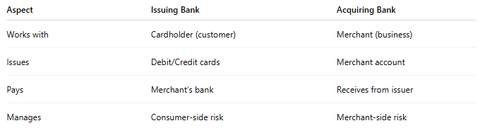

Aspect | Issuing Bank | Acquiring Bank
Works with | Cardholder (customer) | Merchant (business)
Issues | Debit/Credit cards | Merchant account
Pays | Merchant’s bank | Receives from issuer
Manages | Consumer-side risk | Merchant-side risk

🧠 Summary
# Source: AI Source: Provided by: [Data Path: Persons Table -> ID Column: 1, Name_En Column: Motasem Essam] -> From: [ChatGPT] on [1/21/2026]
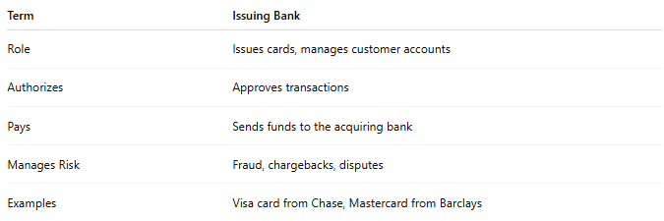

Term | Issuing Bank
Role | Issues cards, manages customer accounts
Authorizes | Approves transactions
Pays | Sends funds to the acquiring bank
Manages Risk | Fraud, chargebacks, disputes
Examples | Visa card from Chase, Mastercard from Barclays

Would you like a diagram of the payment flow involving the issuing bank and others (like the card network and acquiring bank)?

